# Chapter 5: Testing

## Introduction

Testing is an action to analyze the functionality of a software application in order to find out the specified requirements that the developed software has met or not and in order to produce the quality software, weakness is identify to assure that the product is defect free.

There are different types of testing but I have used unit testing and black box testing which have their own features and goals for testing.

**Test case**: It is a document of test data, precondition, expected results, actual results and outcome as expected.

Advantage of test case:

* Time-saving.
* Provide good quality software.
* Reduce weakness.

## Unit testing

Unit testing is software testing by breaking the program into units and subjecting each unit to a series of test. Usually tests are run as separate operation but the testing method is different based upon the language and the software.

White box is known as code-based testing in which the internal structure of the several programming and coding is tested. This testing is also known as unit testing. The unit testing for my supermarket is given below.

## Blackbox testing

Blackbox testing is a way of software testing method that test the internal functionality of a develop application. This is also known as specification based testing. Functionality of my application that I have tested is given below.

1. Registration

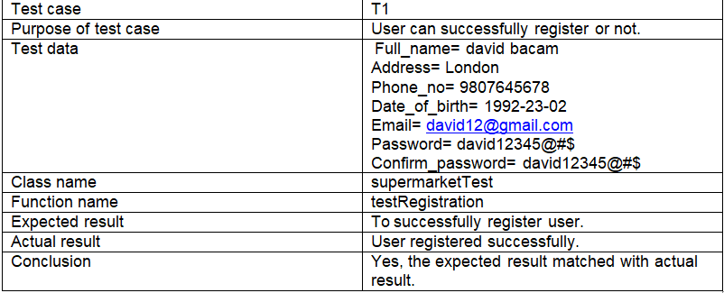

Figure : Registration test log.

Unit testing:

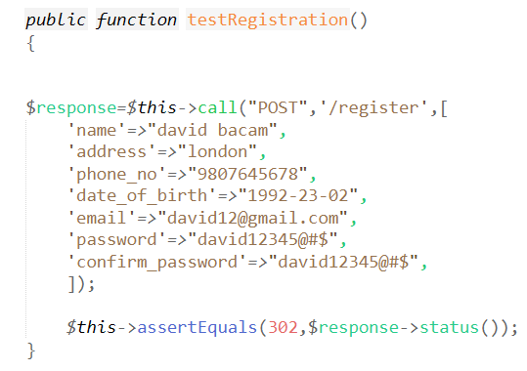

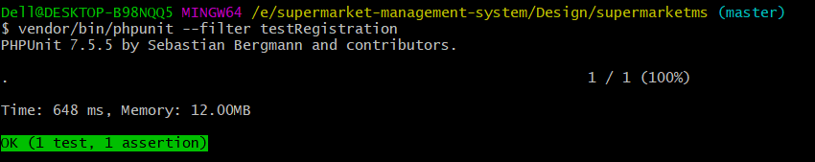

Figure : Registration unit testing.

Blackbox testing:

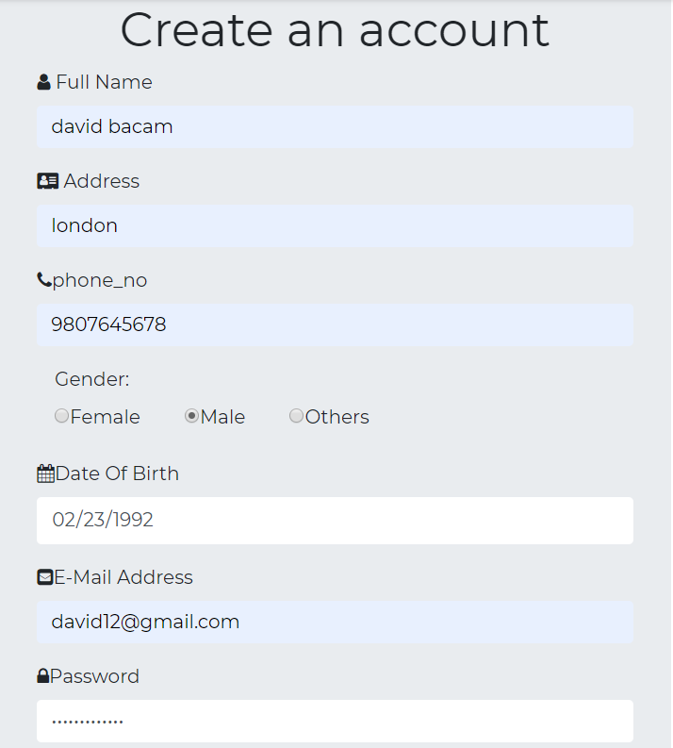

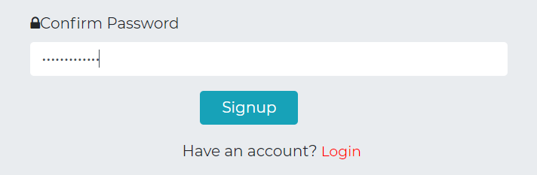

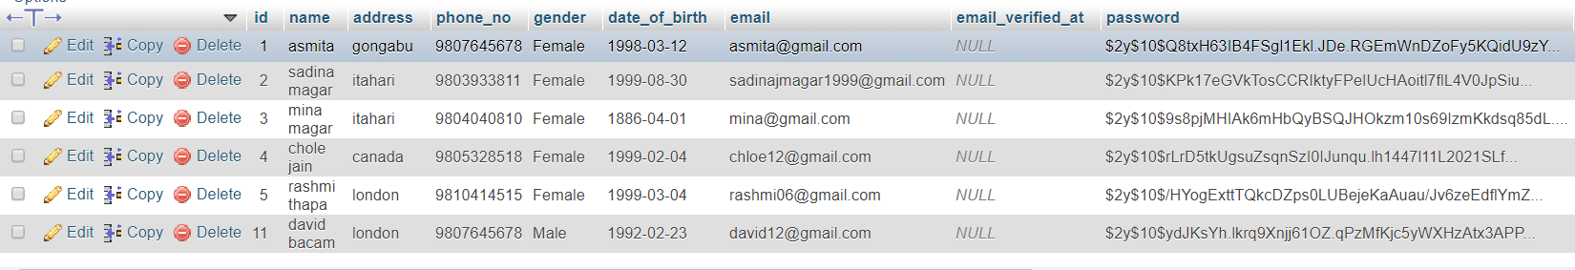

Output:

Figure : Registration black-box testing.

2. Login

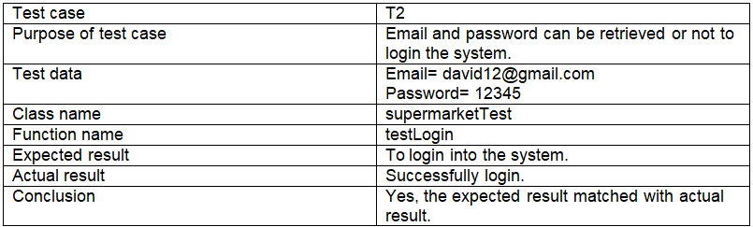

Figure : Login test log.

Unit testing:

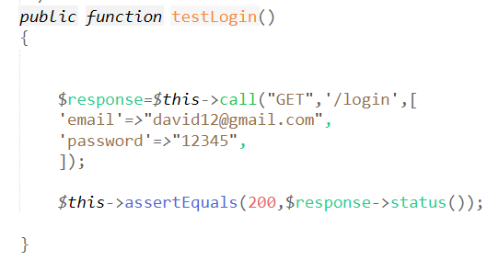

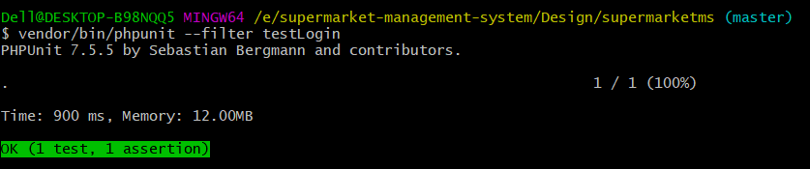

Figure : Login unit testing.

Blackbox testing:

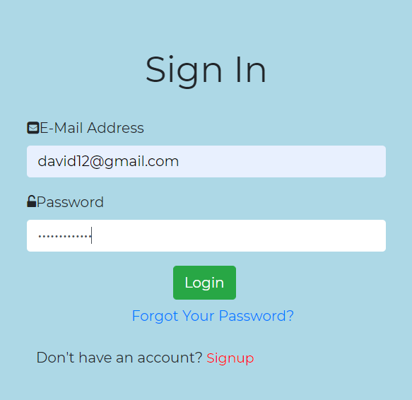

Output:

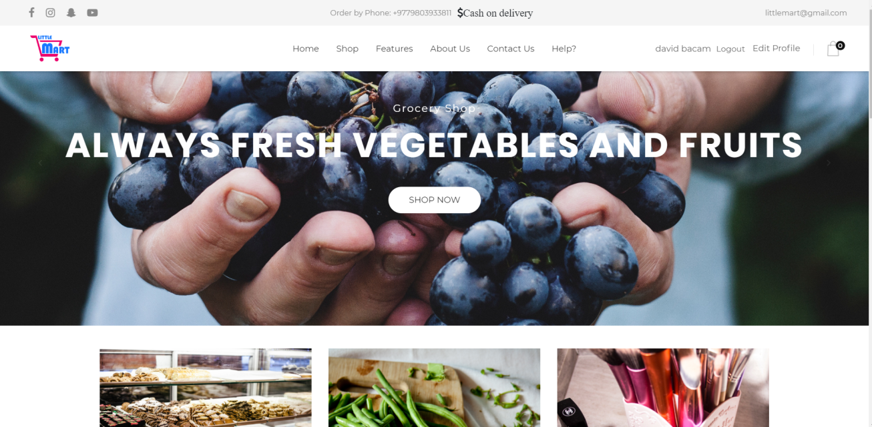

Figure : Login black-box testing.

3. Registration validation form

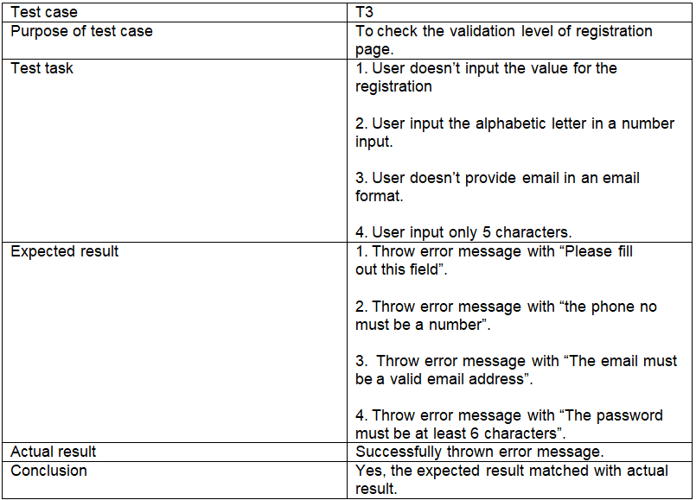

Figure : validation level of registration test log.

Blackbox testing:

Output:

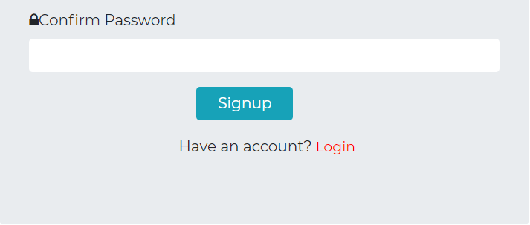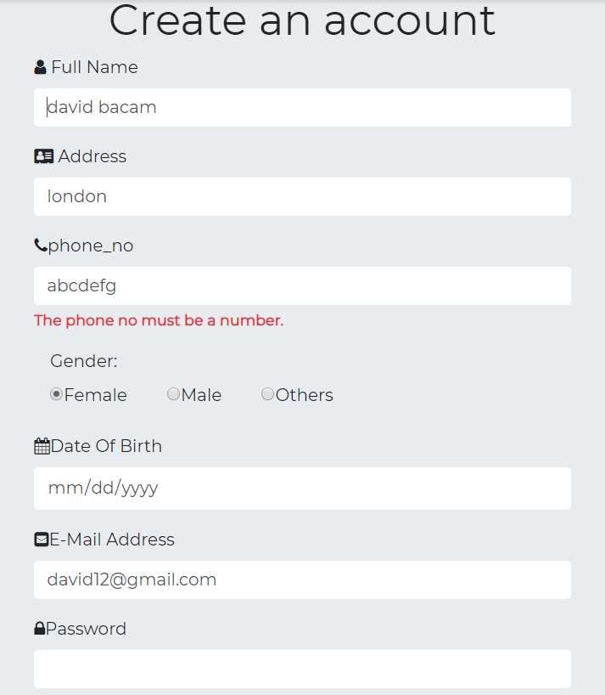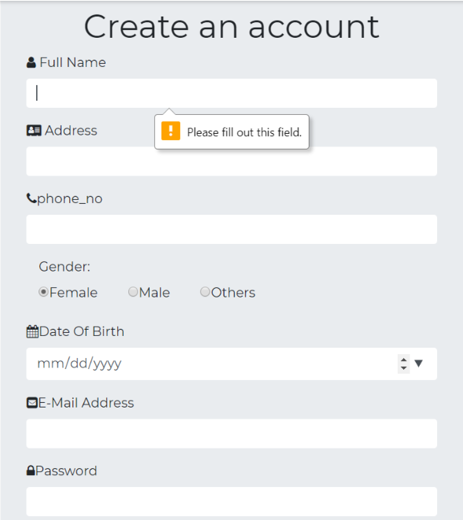

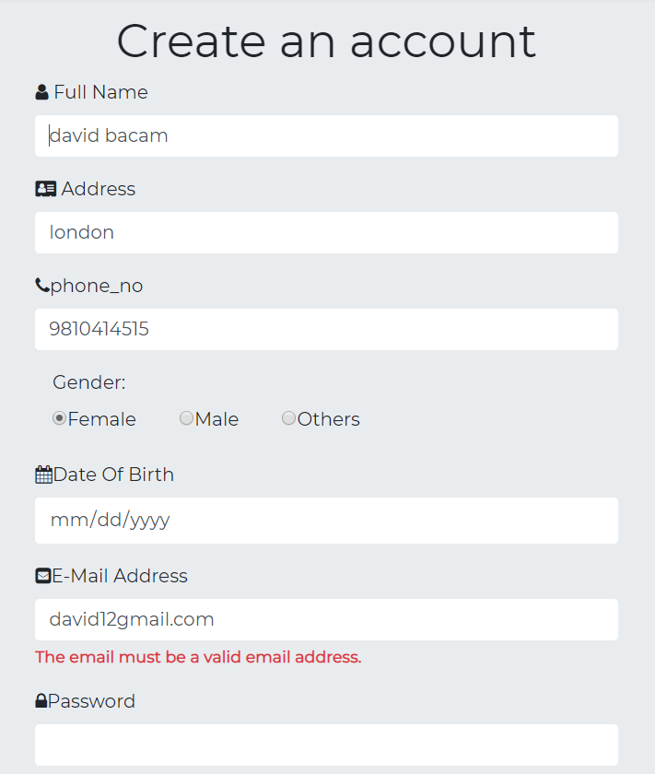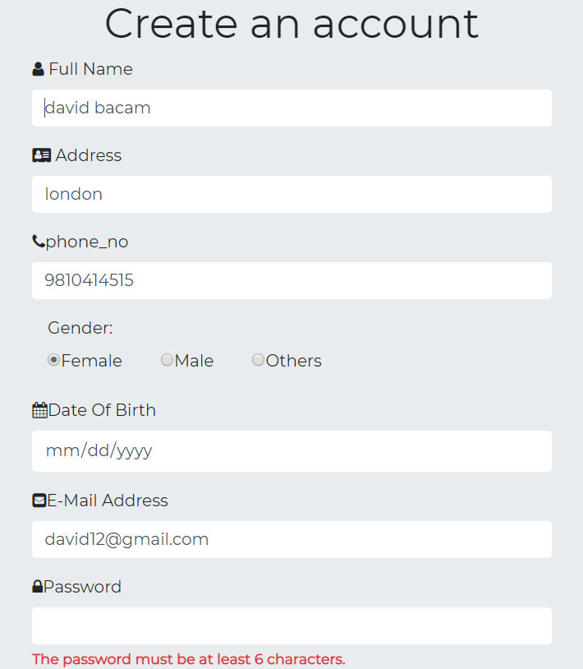

Figure : Validation level of registration black-box testing.

4. Validation of product form

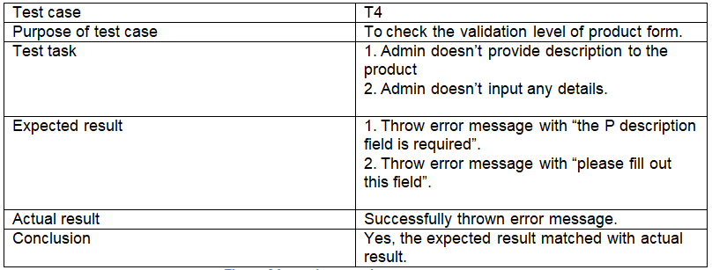

Figure : product test log.

Blackbox testing:

Output:

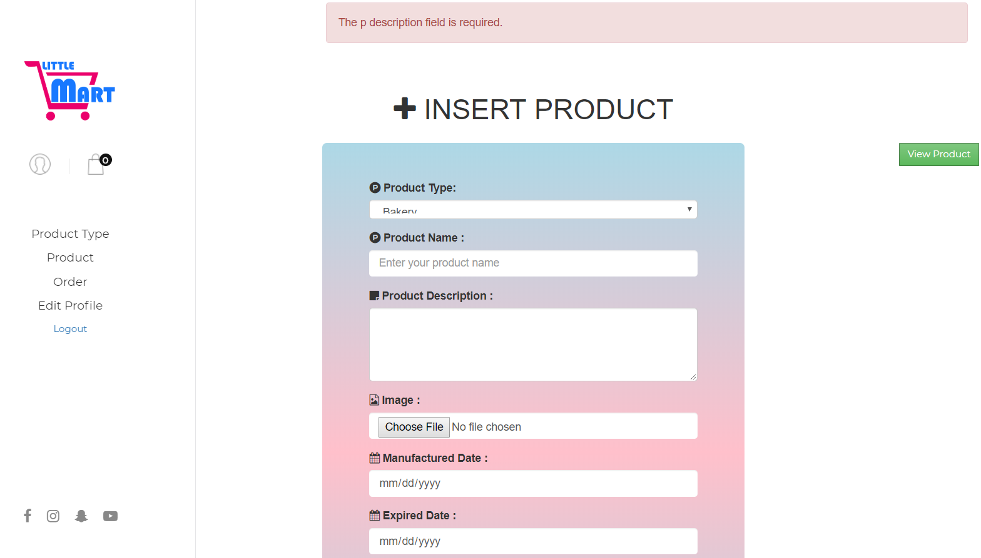

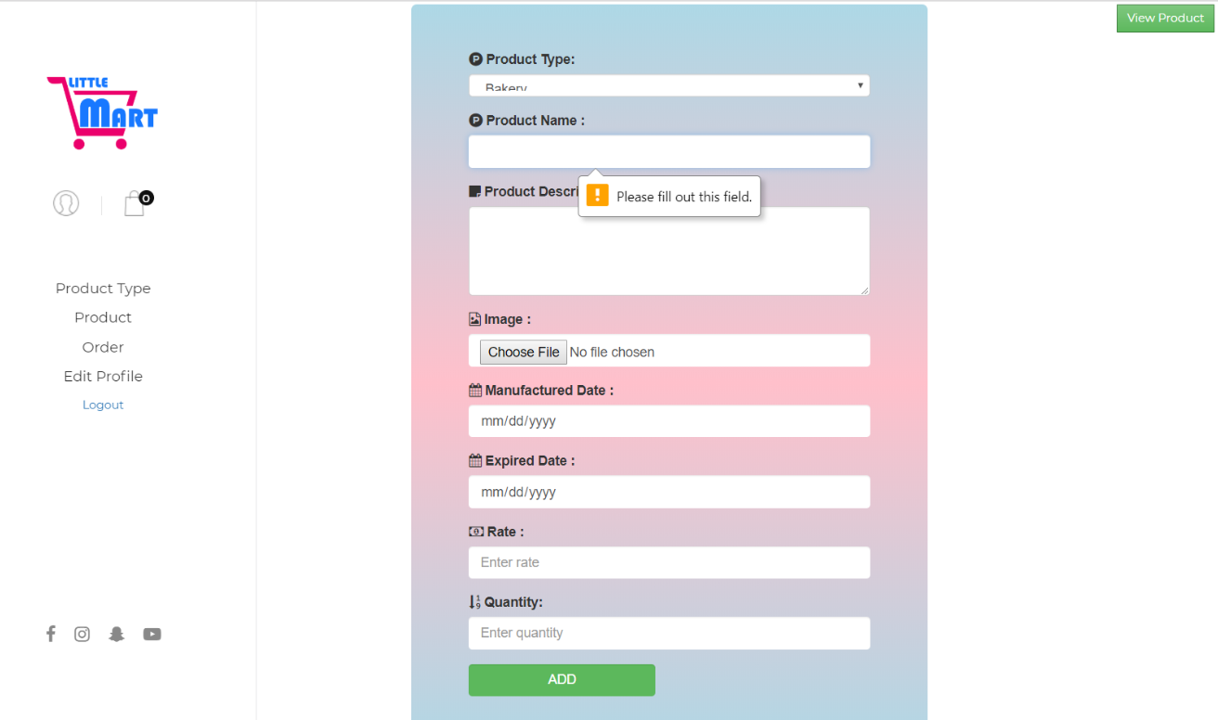

Figure : product form black-box testing.

5. Add product

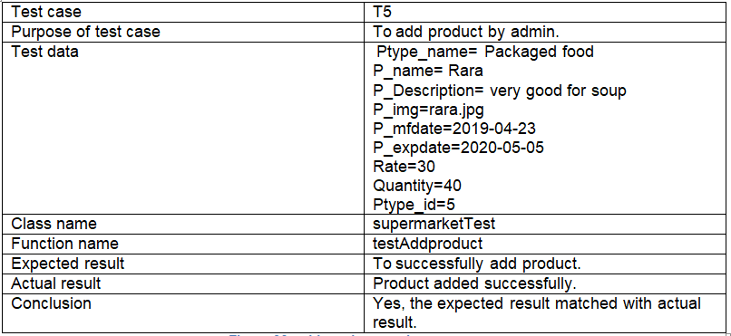

Figure : add product test log.

Unit testing:

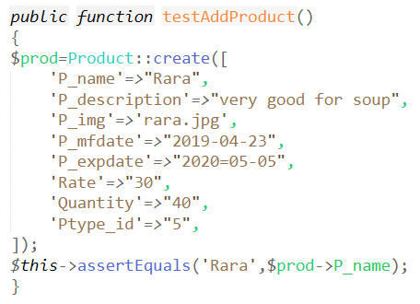

Output:

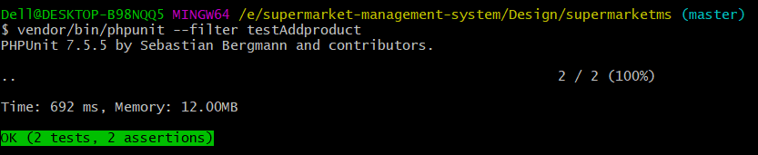

Figure : add product unit testing.

Blackbox testing:

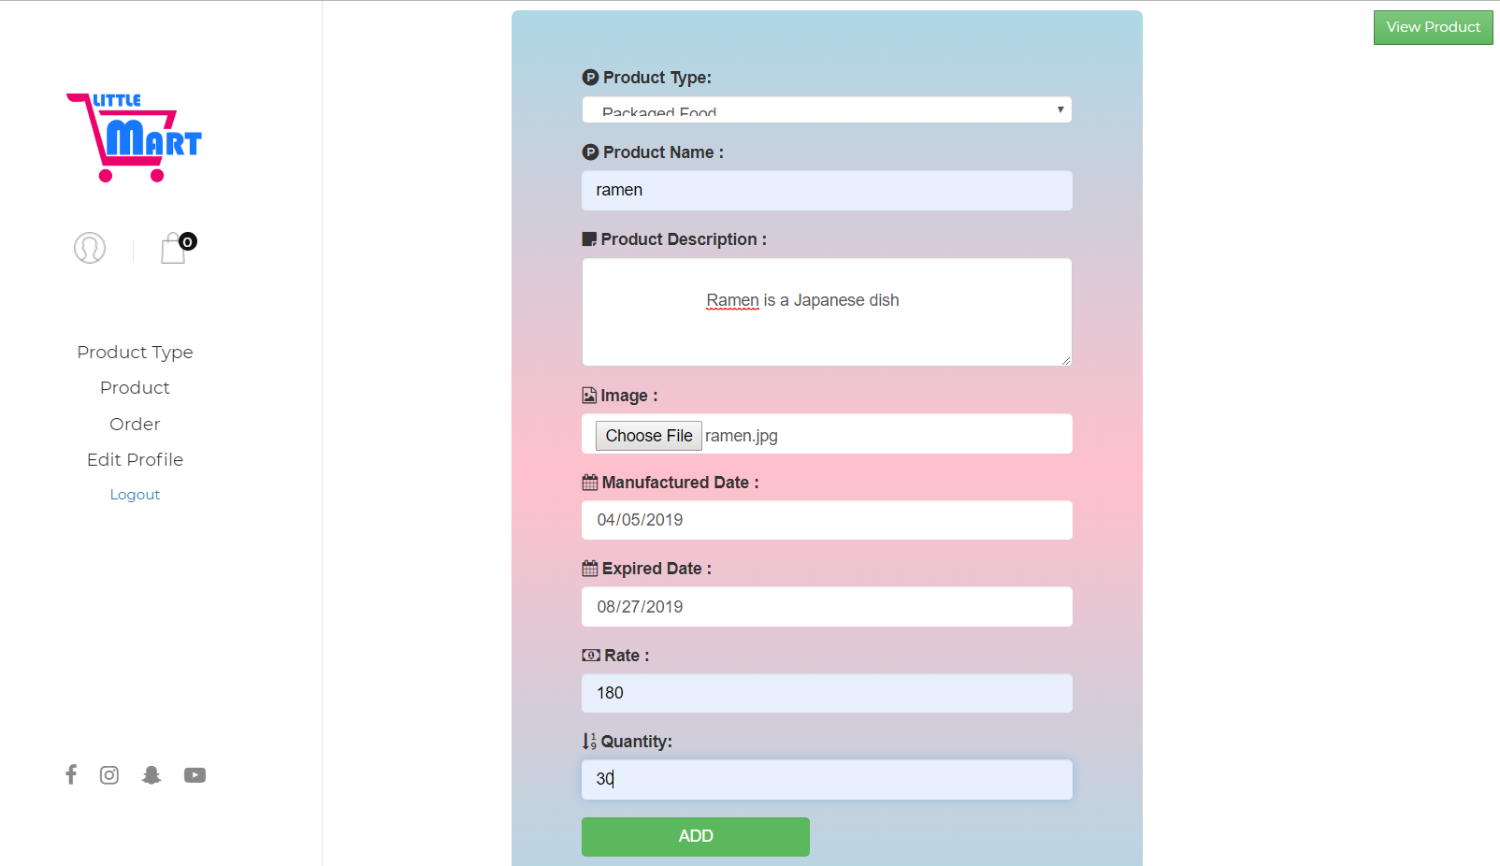

Output:

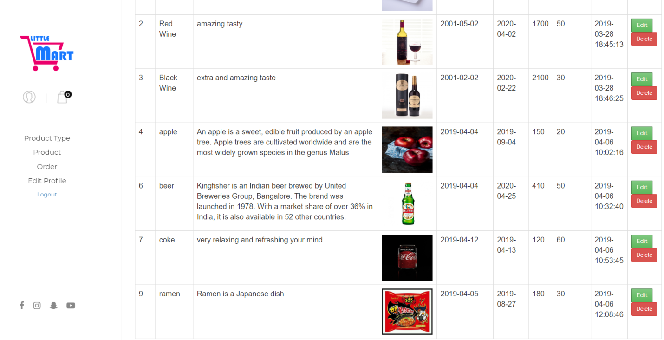

Figure : add product black-box testing.

6. Add product type

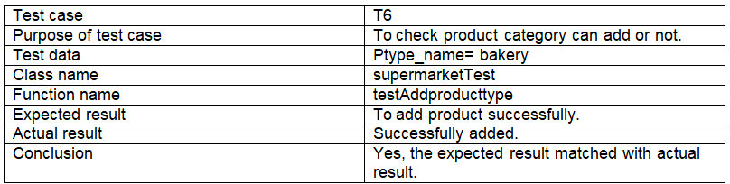

Figure : product type test log.

Unit testing:

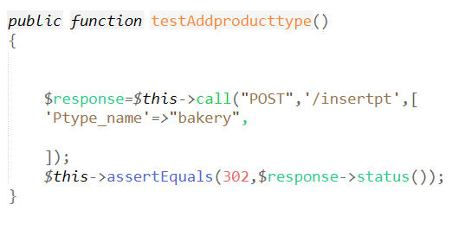

Output:

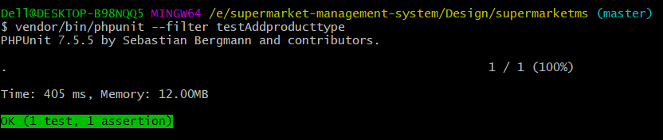

Figure : Add product type unit testing.

Blackbox testing:

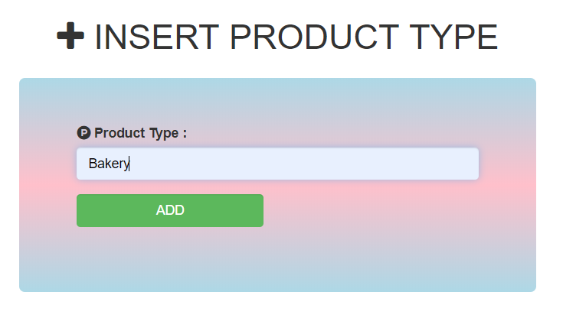

Output:

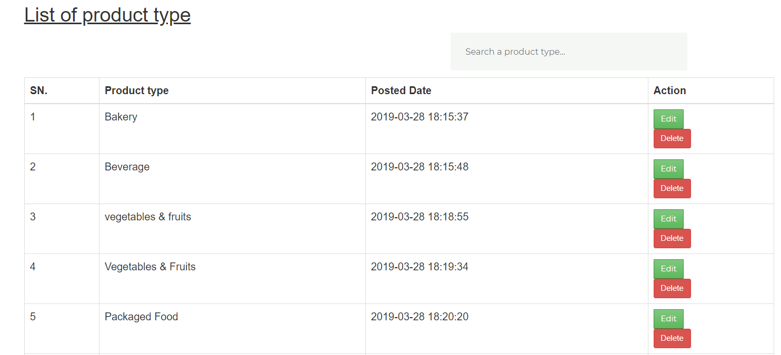

Figure : Add product type black box testing.

7. Update product type

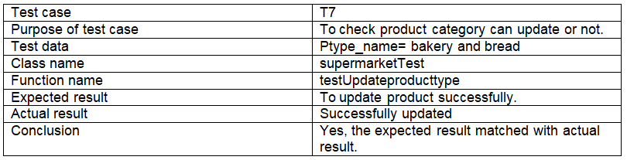

Figure : update product type test log.

Unit testing:

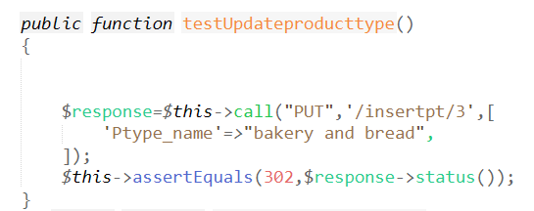

Output:

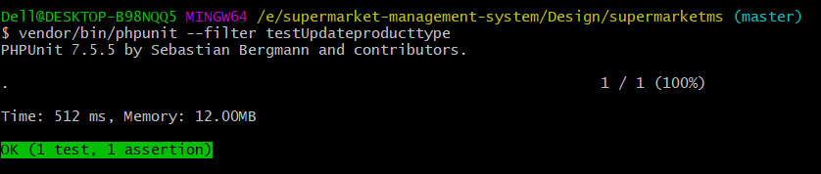

Figure : update product unit testing.

Blackbox testing:

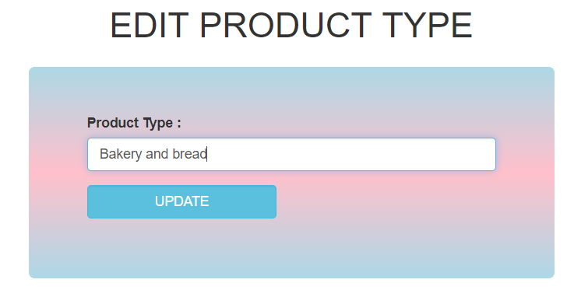

Output:

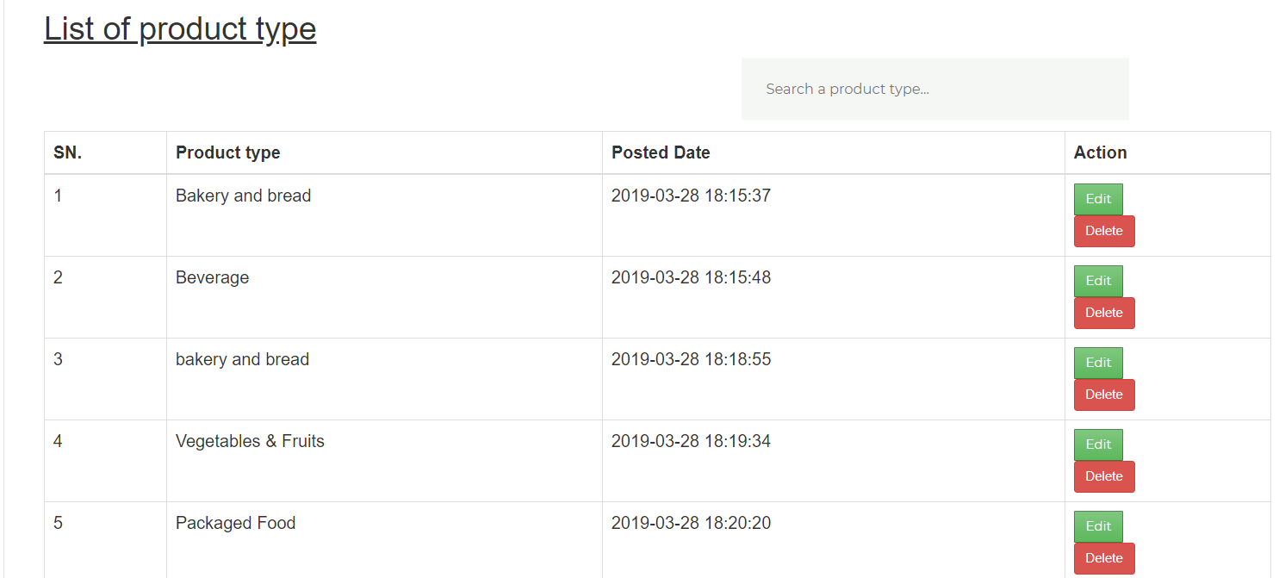

Figure : product updates black box testing.

8. Delete product type

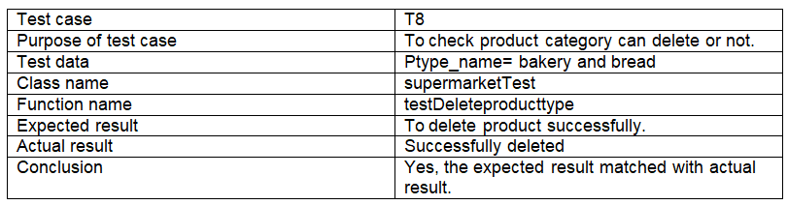

Figure : delete product type test log.

Unit testing:

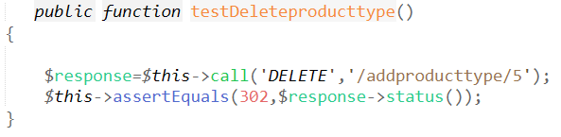

Output:

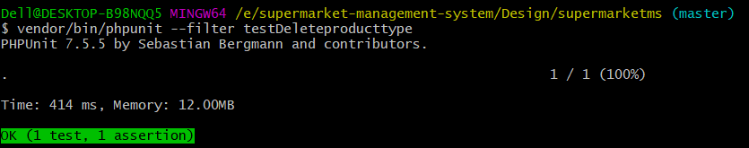

Figure : delete product type unit testing.

Blackbox testing:

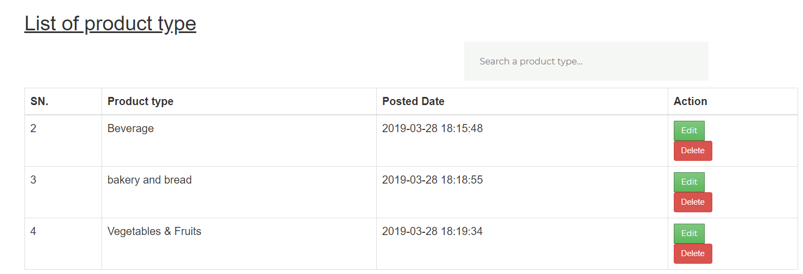

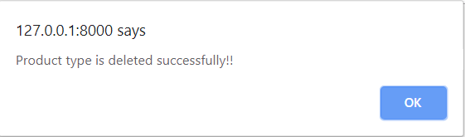

Figure : delete product type black box testing.

9. Add to cart

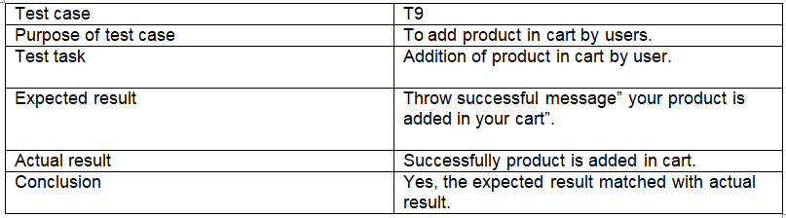

Figure : add cart test log.

Blackbox testing:

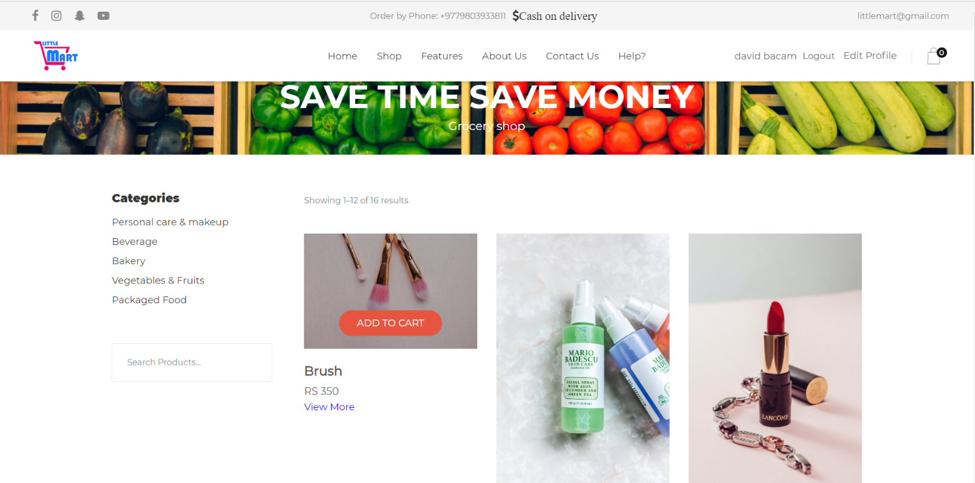

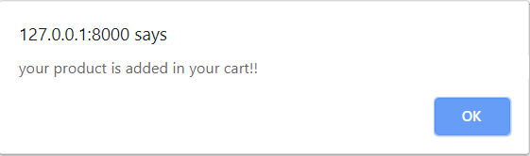

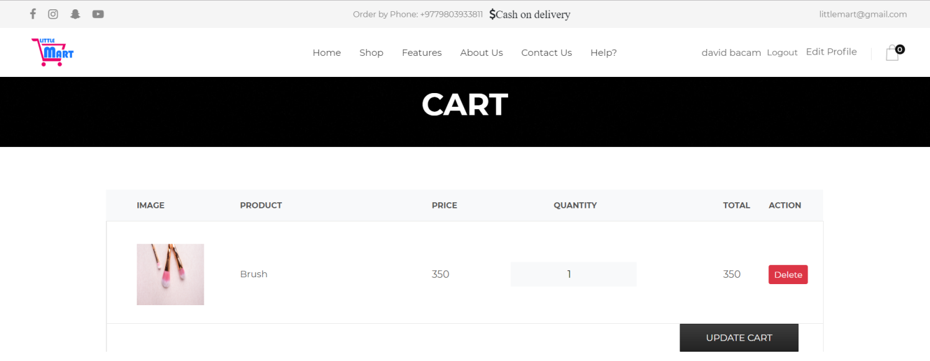

Figure : add cart black- box testing.

9. Database data

10. Database

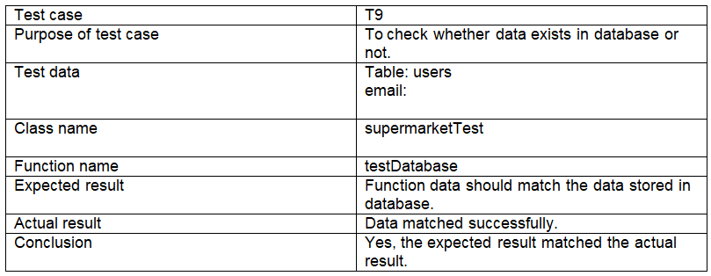

Figure : database data test log.

Unit testing:

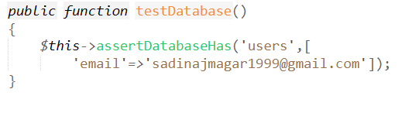

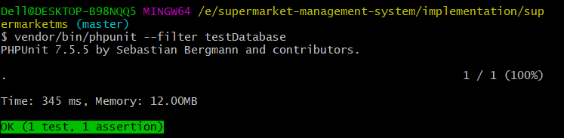

Figure : database data unit testing.

11. Visit page

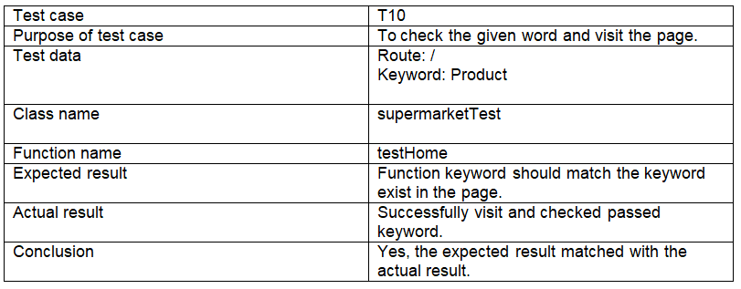

Figure : visit page test log.

Unit testing:

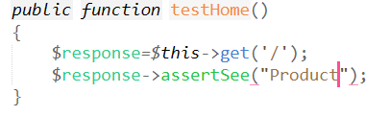

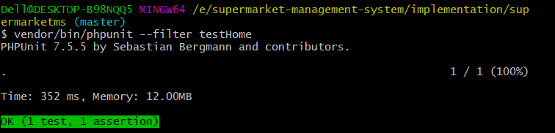

Figure : visit page unit testing.

12. Route

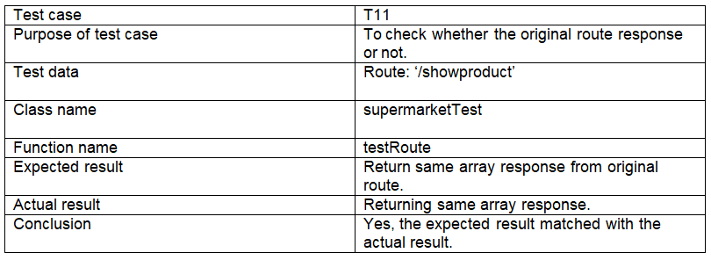

Figure : Response route test log.

Unit testing:

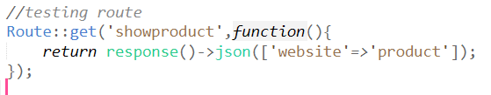

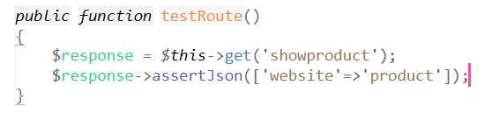

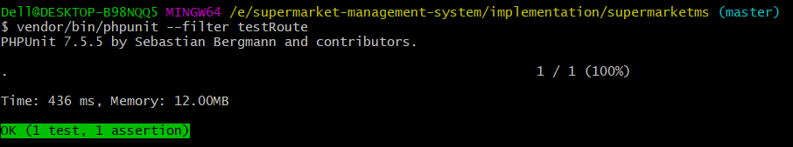

Figure : Response route unit testing.

13. Contact

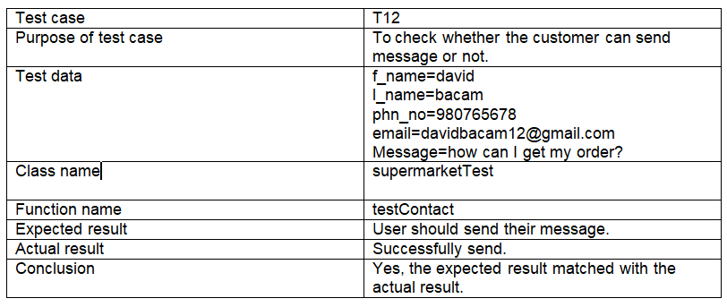

Figure : Send message test log.

Unit testing:

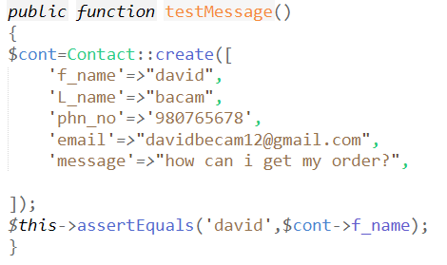

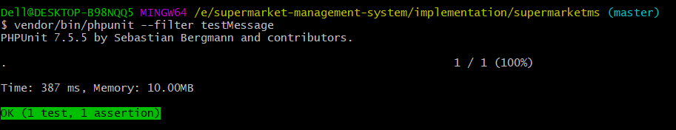

Figure : Send message unit testing.

Black box testing:

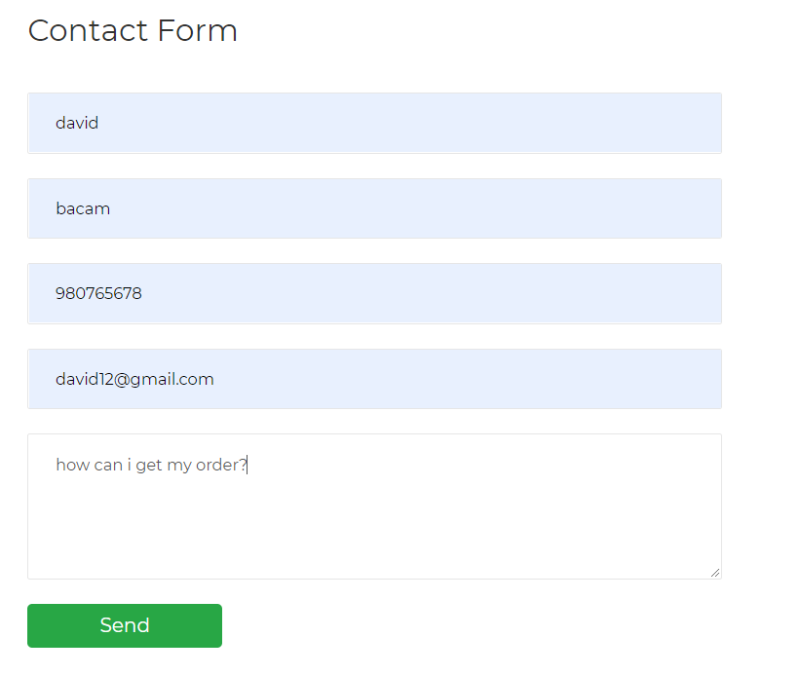

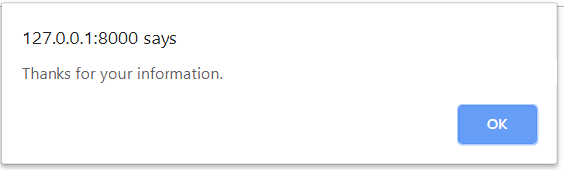

Figure : Send message black box testing.